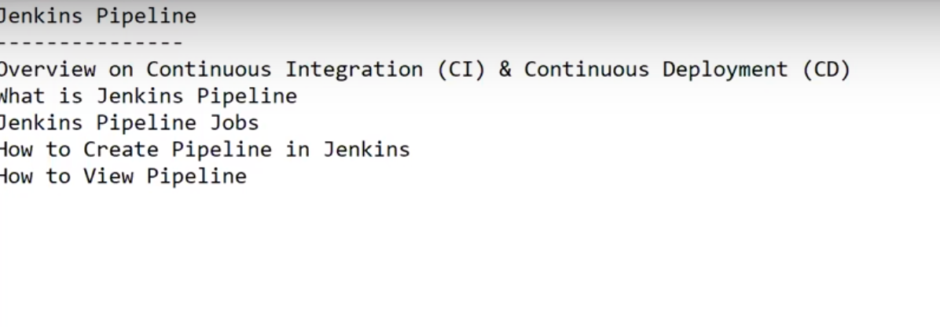

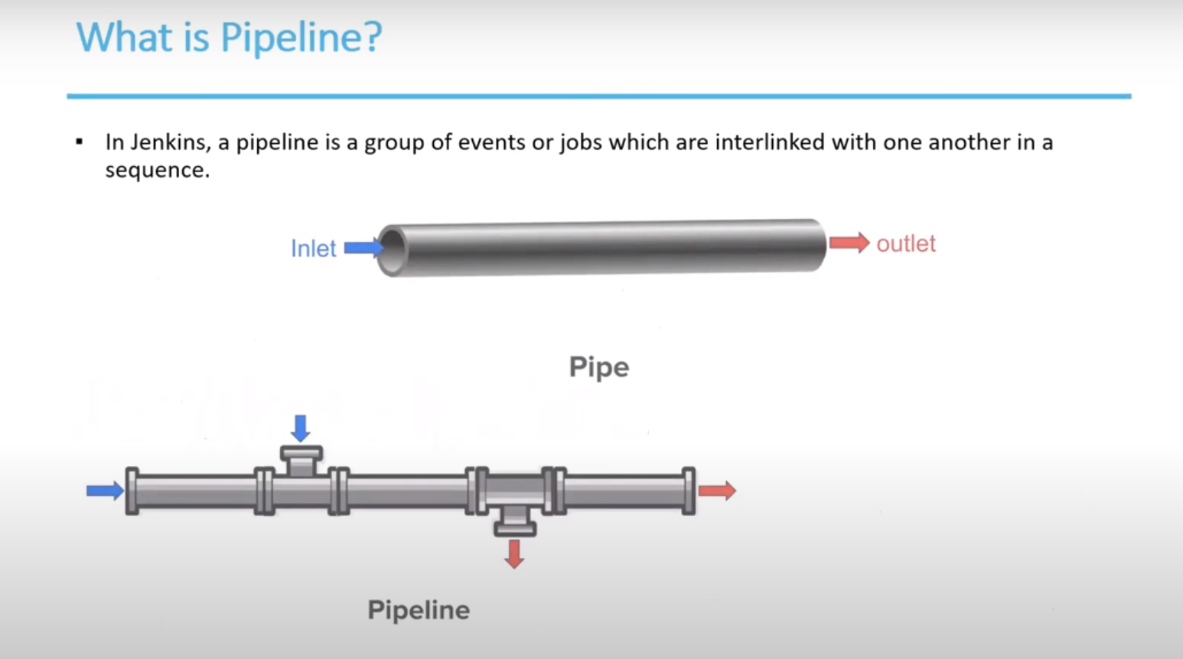

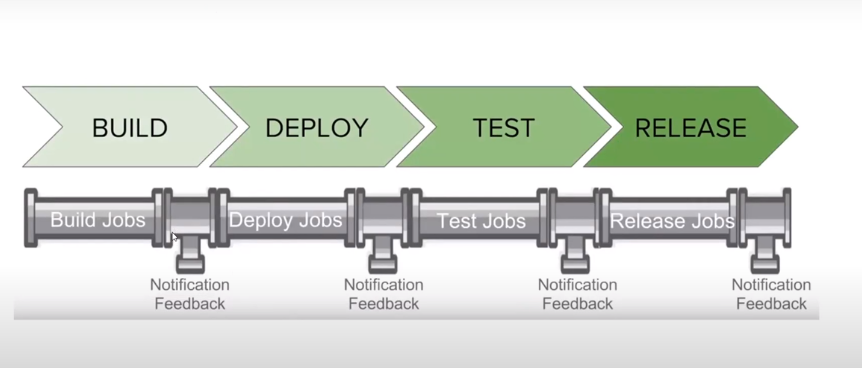

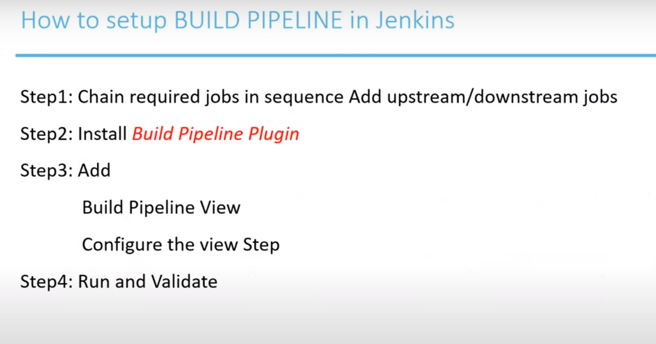

Process to create a job in Jenkins.

Open Jenkins.

Click on NewItem mentioned below:

Enter

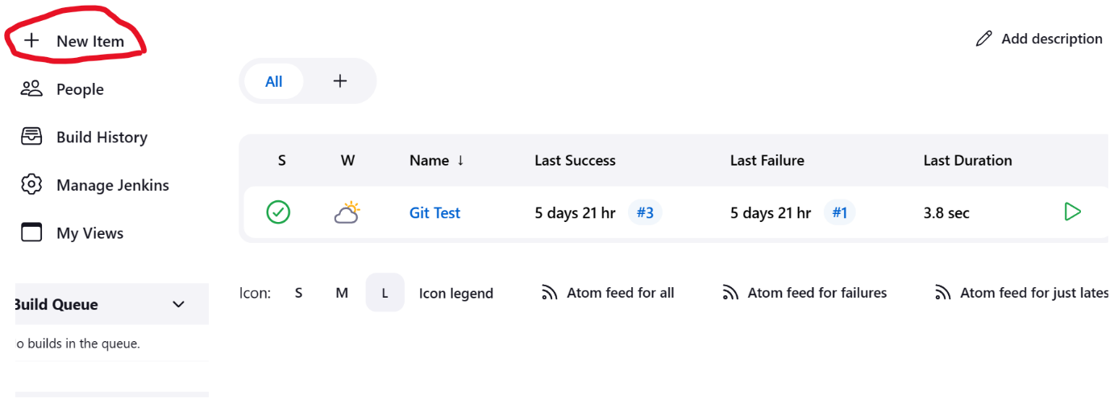

Enter the Job name and click on freestyle project then click ok.

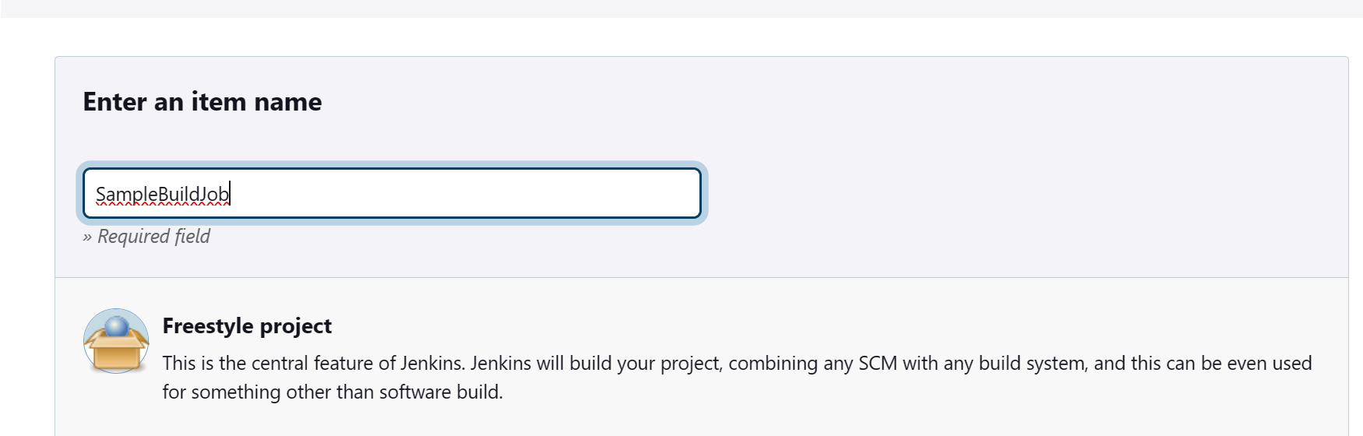

Click on Apply and save.

Repeat the same steps to create another 3 jobs.

SampleDeployJob

SampleTestJob

SampleReleaseJob

Now I need to create a chain.

Add the upstreams and downstreams.

Click on the job which we need to add the upstream.

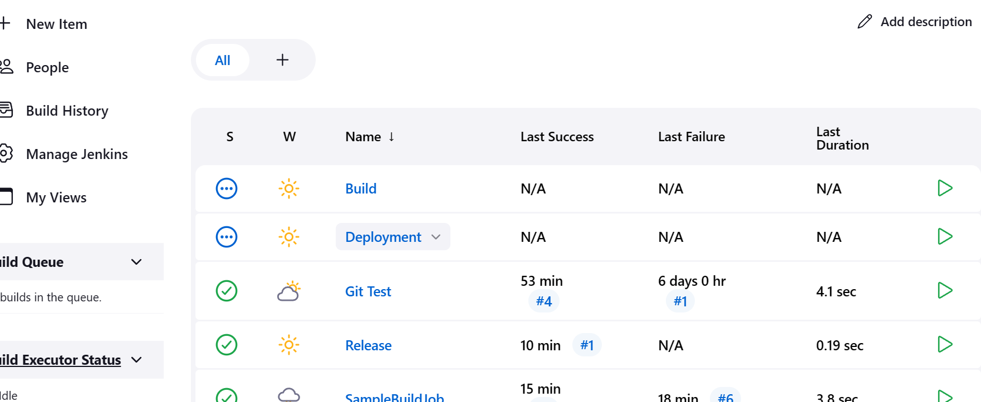

Click on configure.

Add the upstream dependency job in Build trigger.

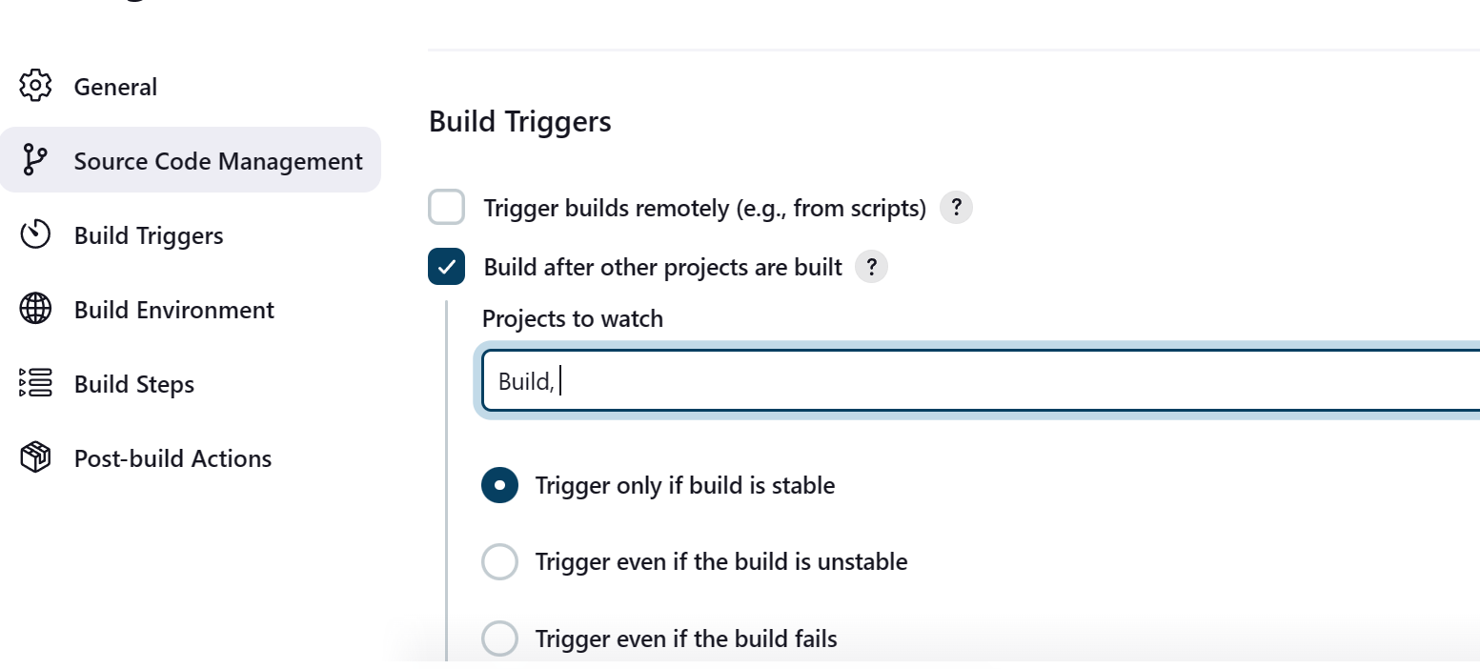

Click Apply and save.

Do the same for other ones

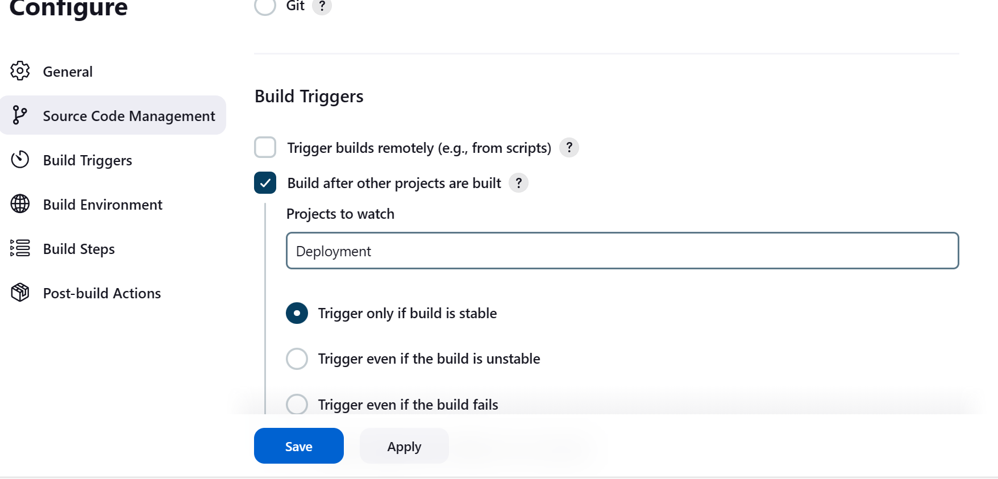

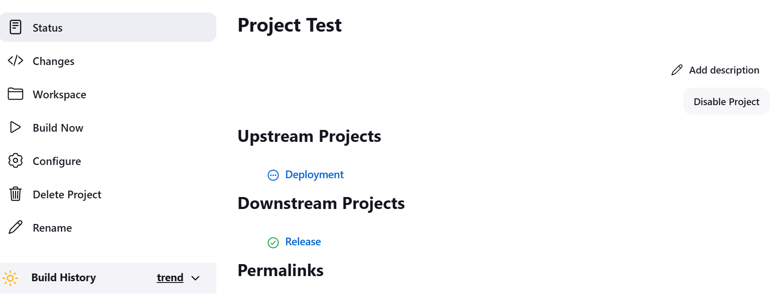

Open all the jobs in window tabs to see the execution line dependency.

Select the first job Build and click on build now and you see it will run one after one.

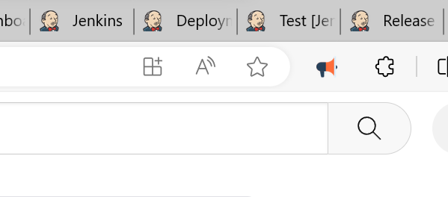

First step is done:

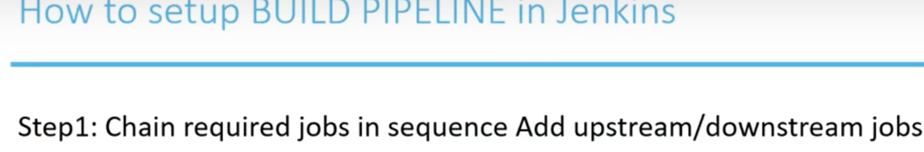

Now I want to create a pipe line and want to execute the jobs automatically one after one.

For Pipe line we need to add one plug in.

Click on manage Jenkins.

Under SystemConfigurations. Click plugins

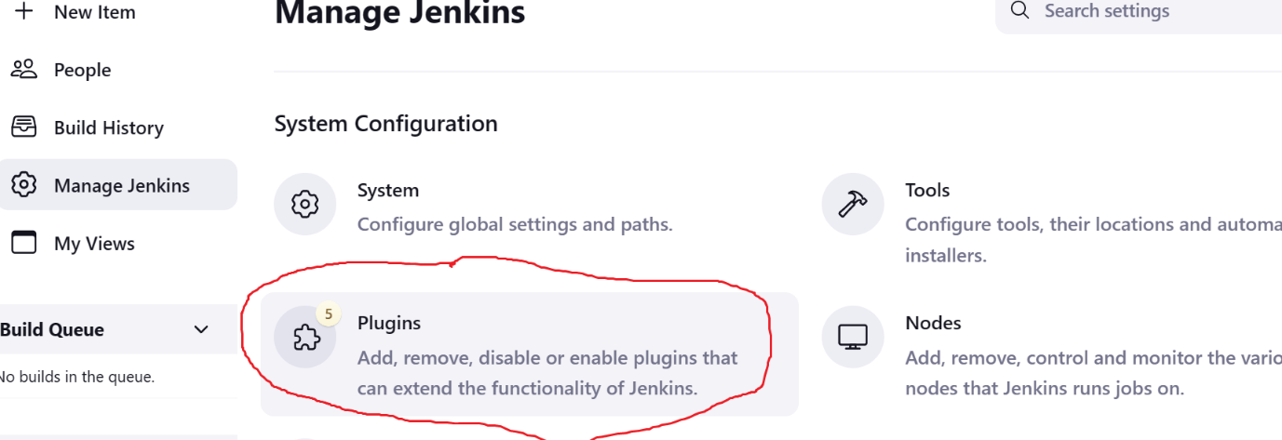

Under plug ins you can find Available plug ins and installed plugins

Installed plug ins means already installed.

I am going for the plug in for GUI part.

Under Available plugin: Enter Build Pipeline

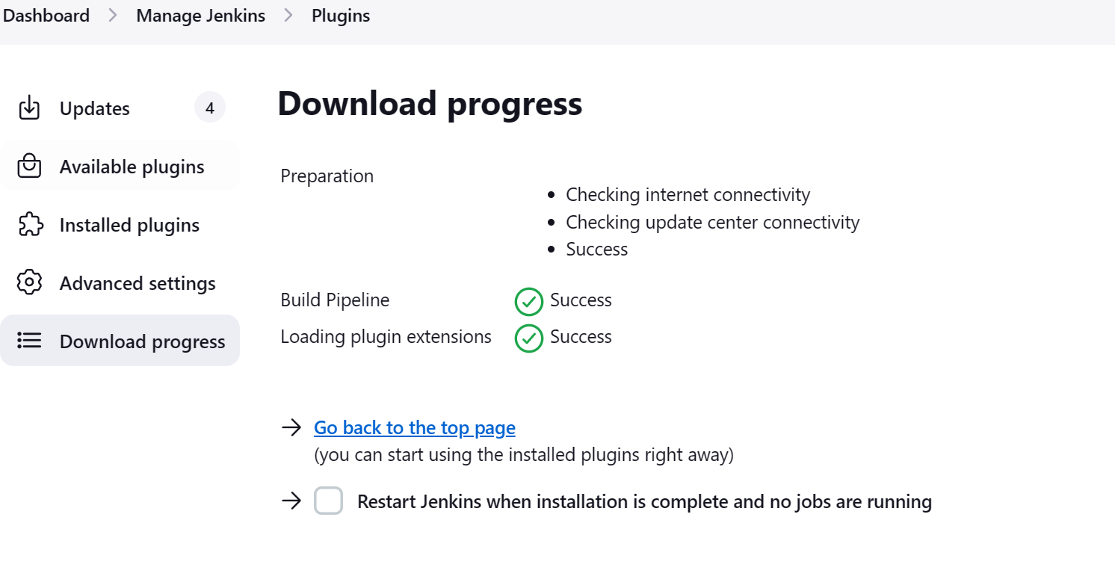

Click on install and restart the jenkin.

In case of a failure in [downloading](Jenkins_plug%20in%20error.docx) the plug ins

After successful installation open the Jenkins

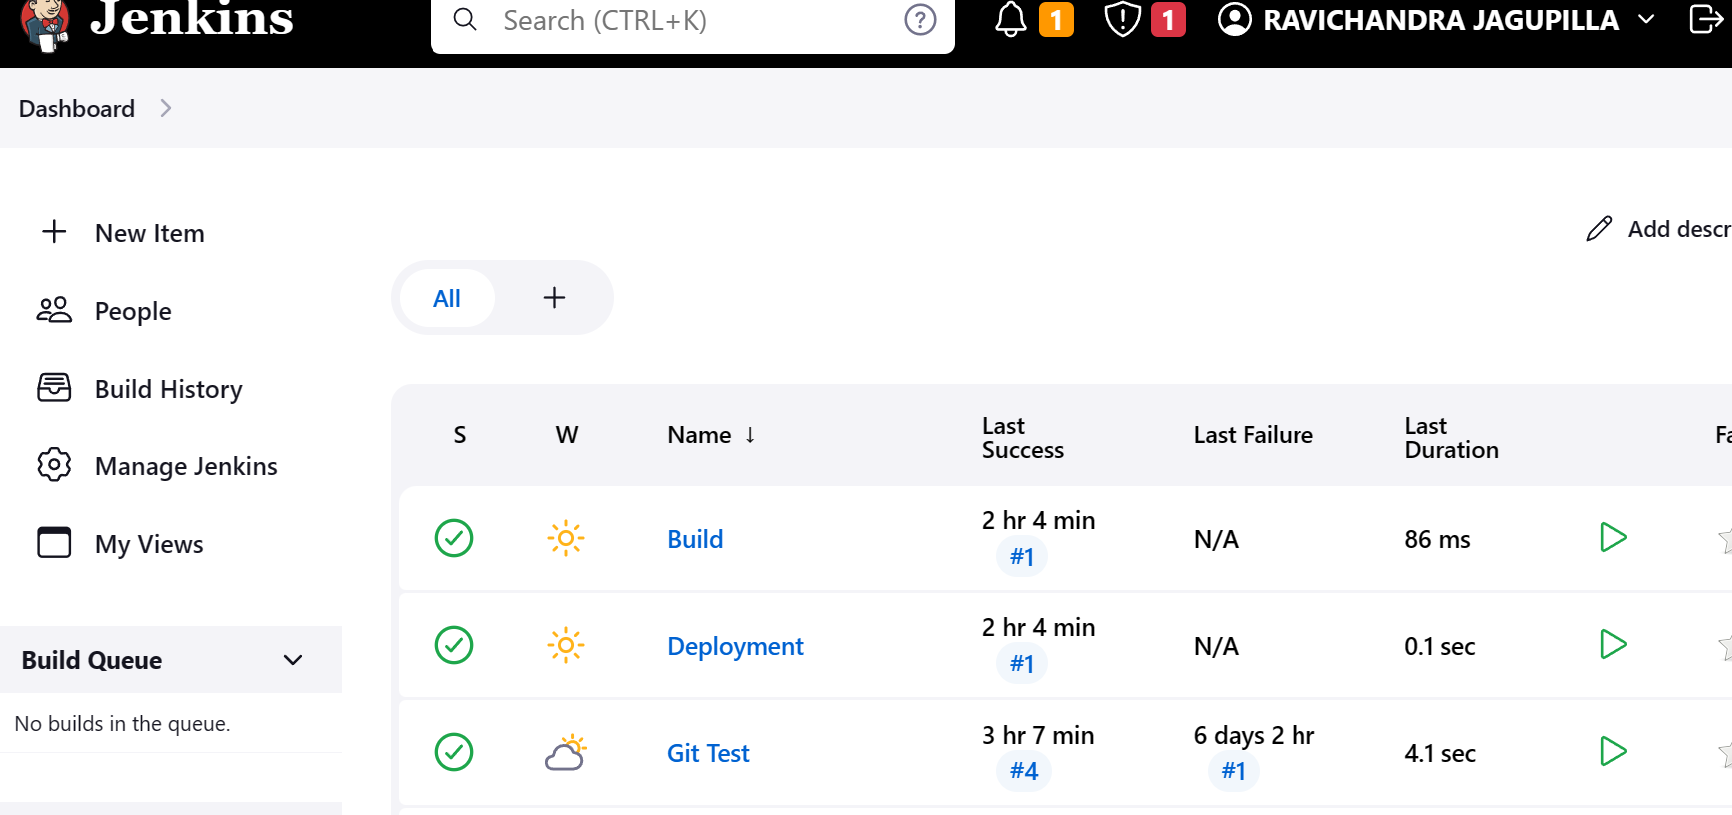

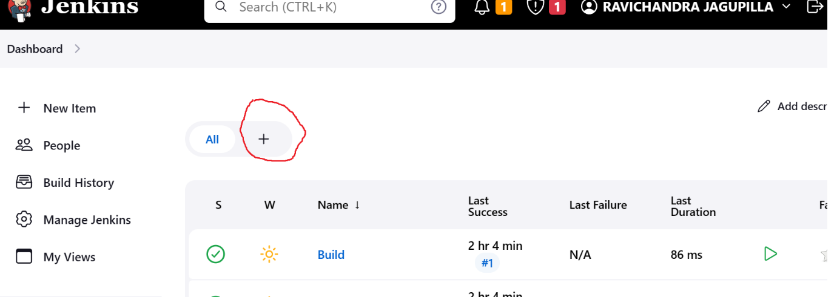

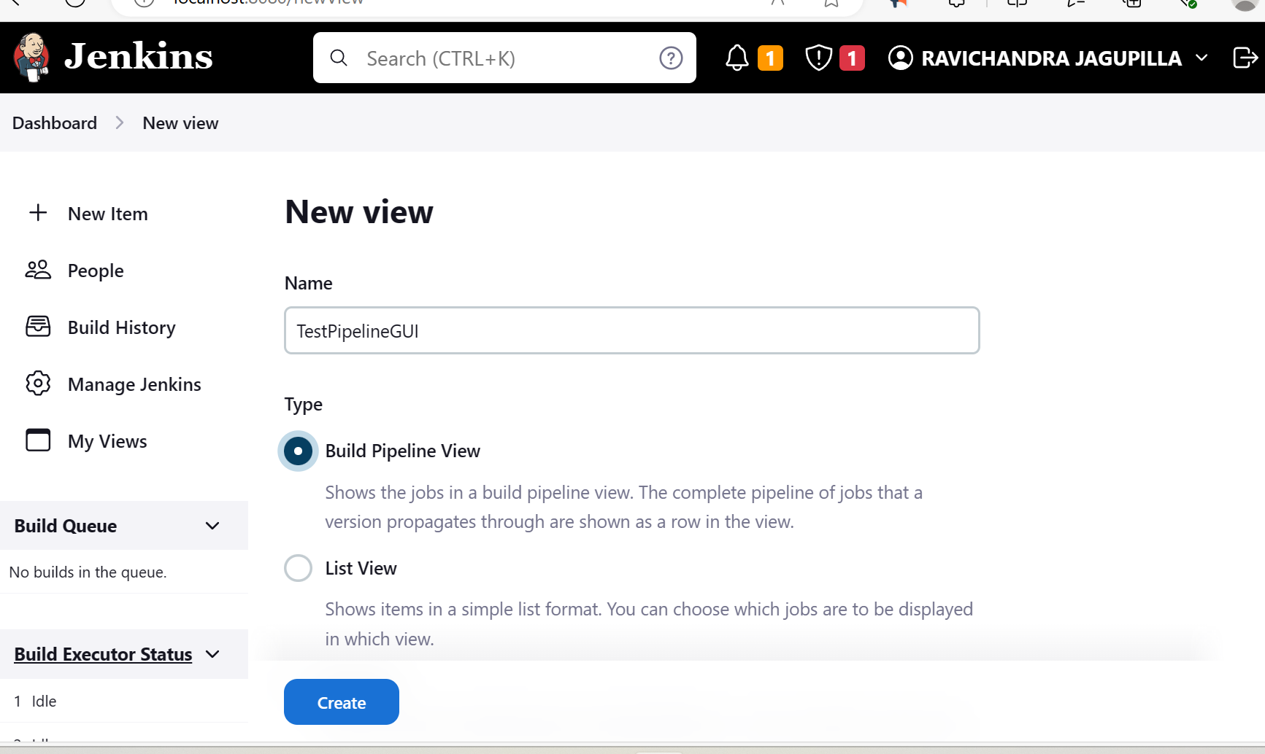

Given the name and click create.

Inside the configuration file you need to select the intial job

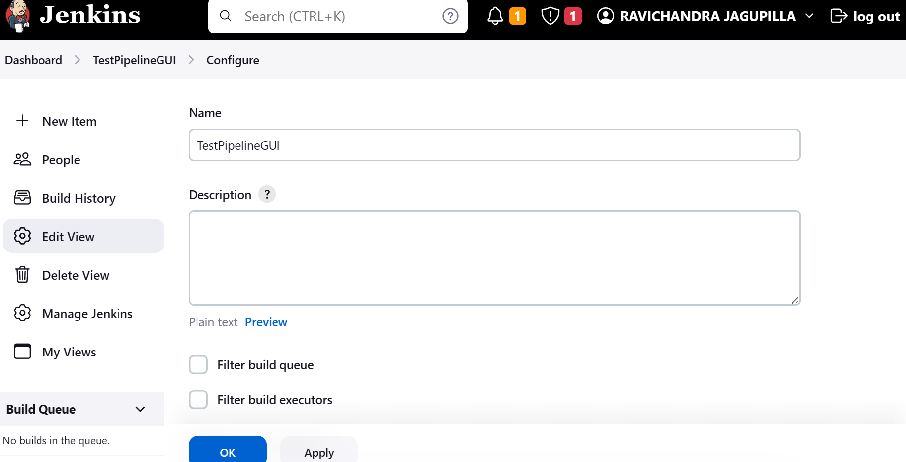

Give the starting process of the selecting the first job to start. In my case Build

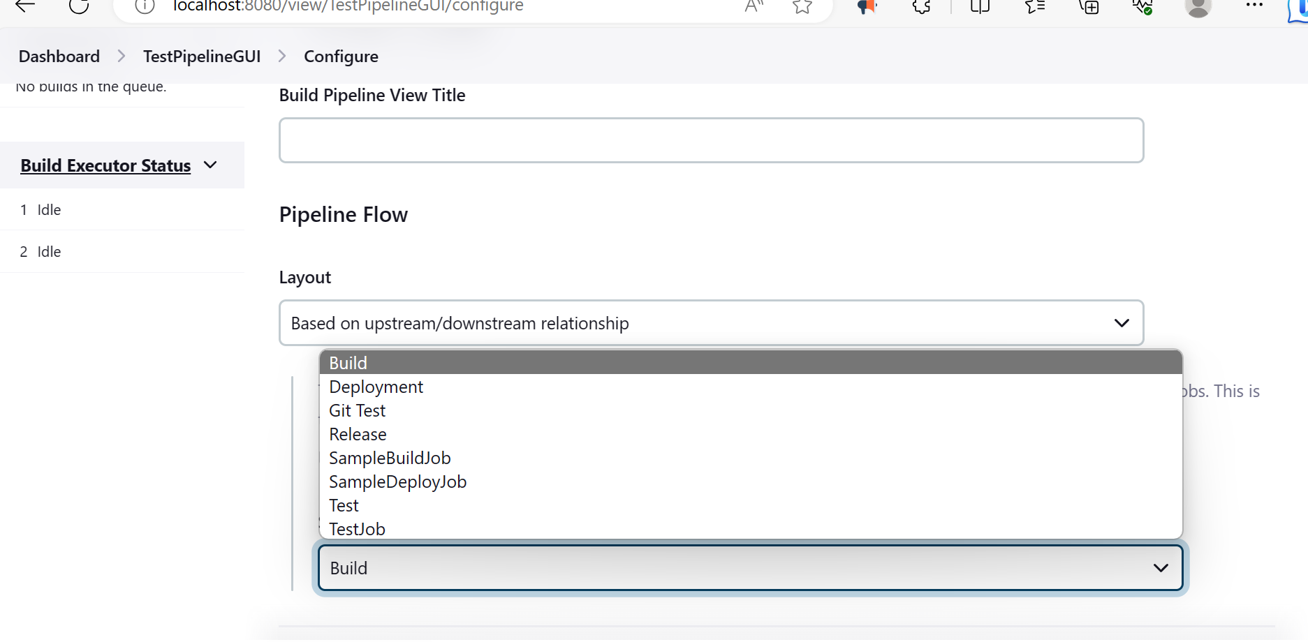

Display number builds at a time to see what is happening.

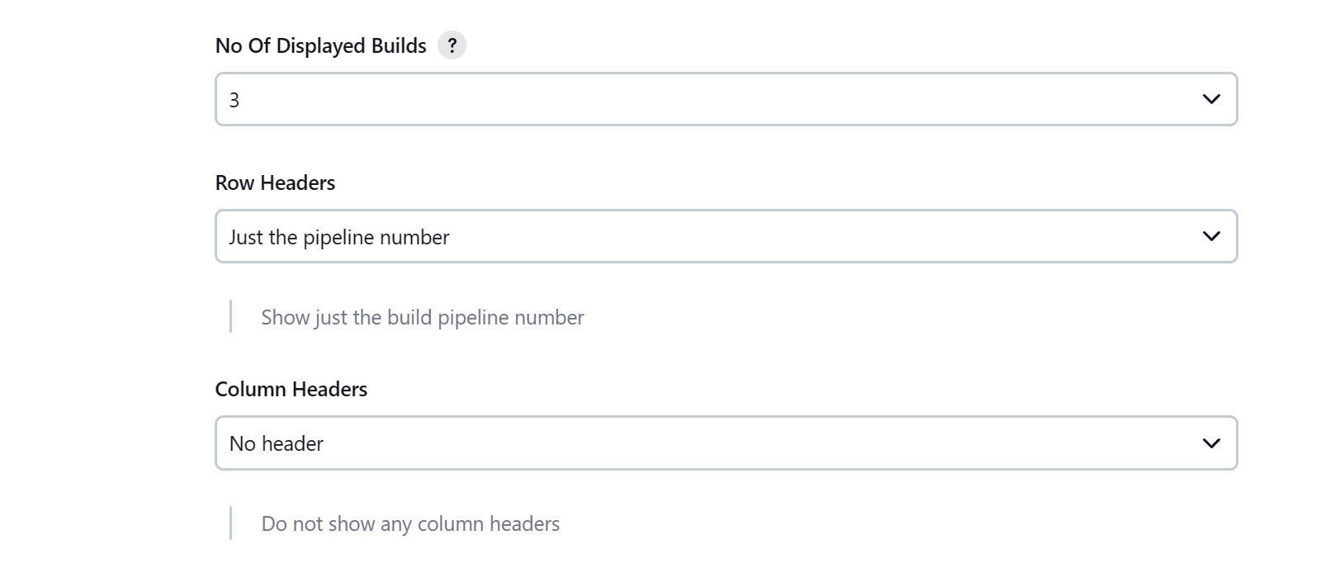

Click Apply and ok

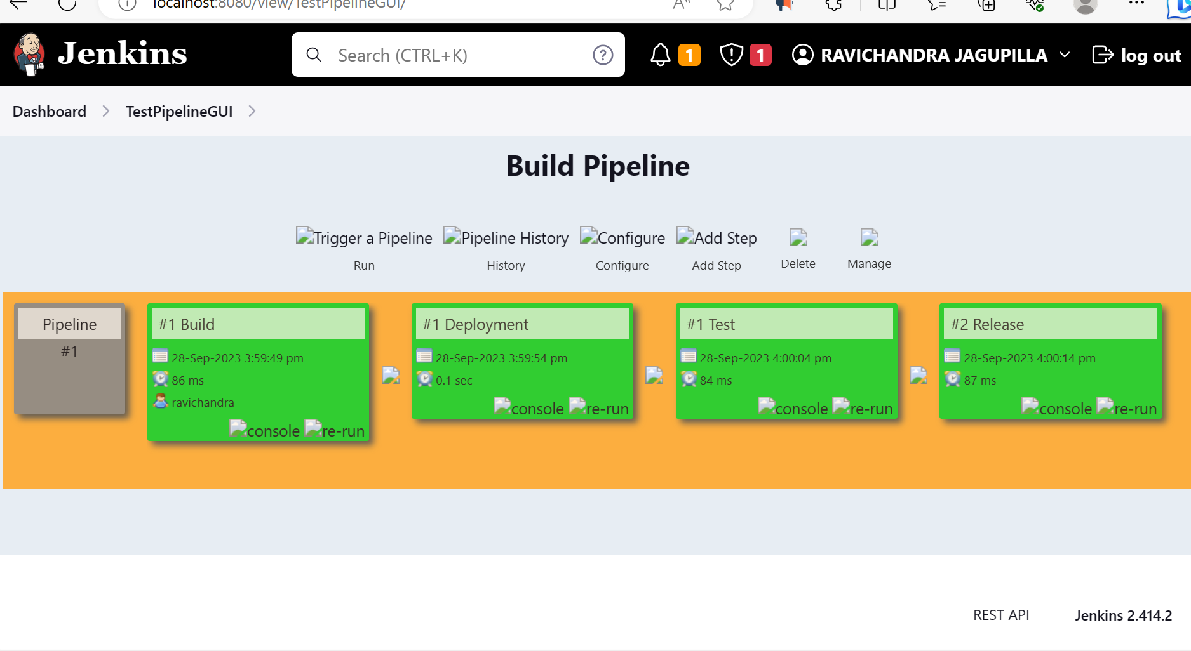

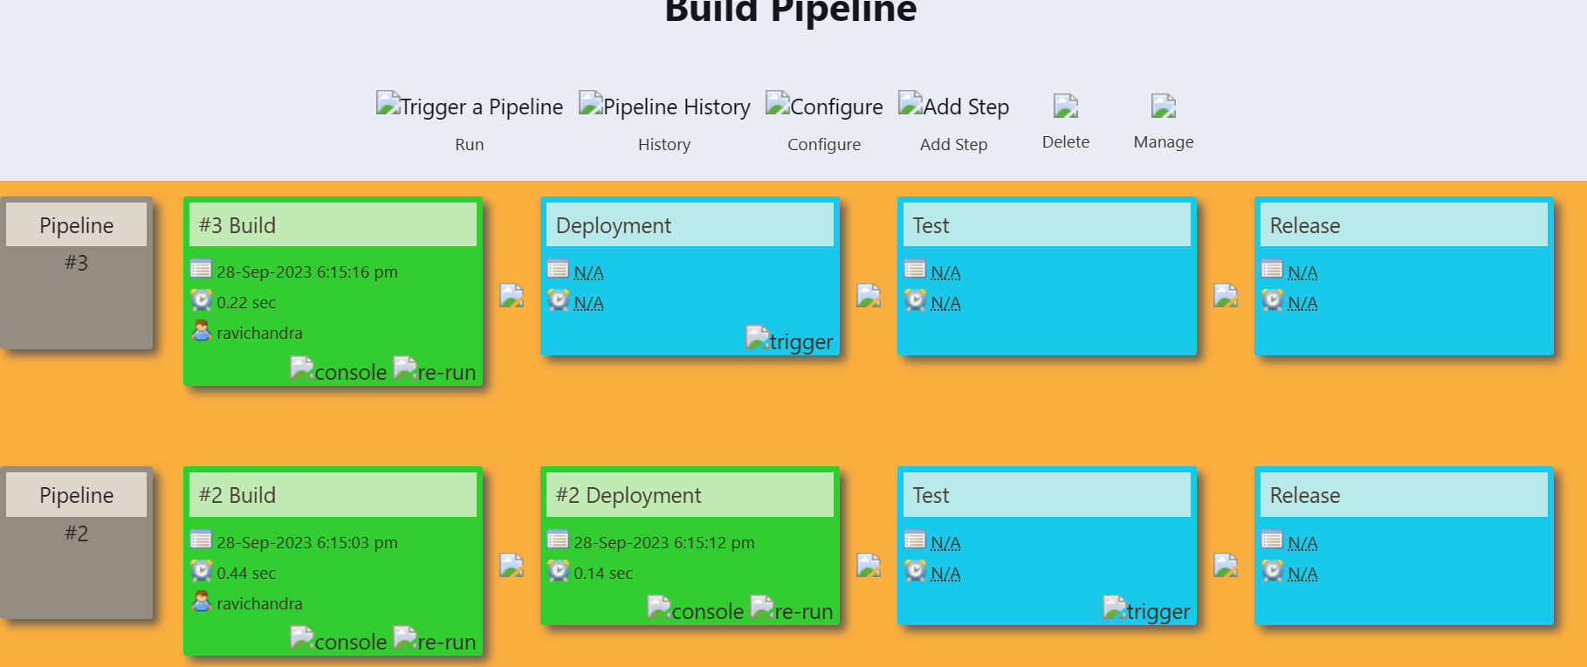click on run to see

Blue indicates still it is not yet done.

Now create another delivery pipe line view.

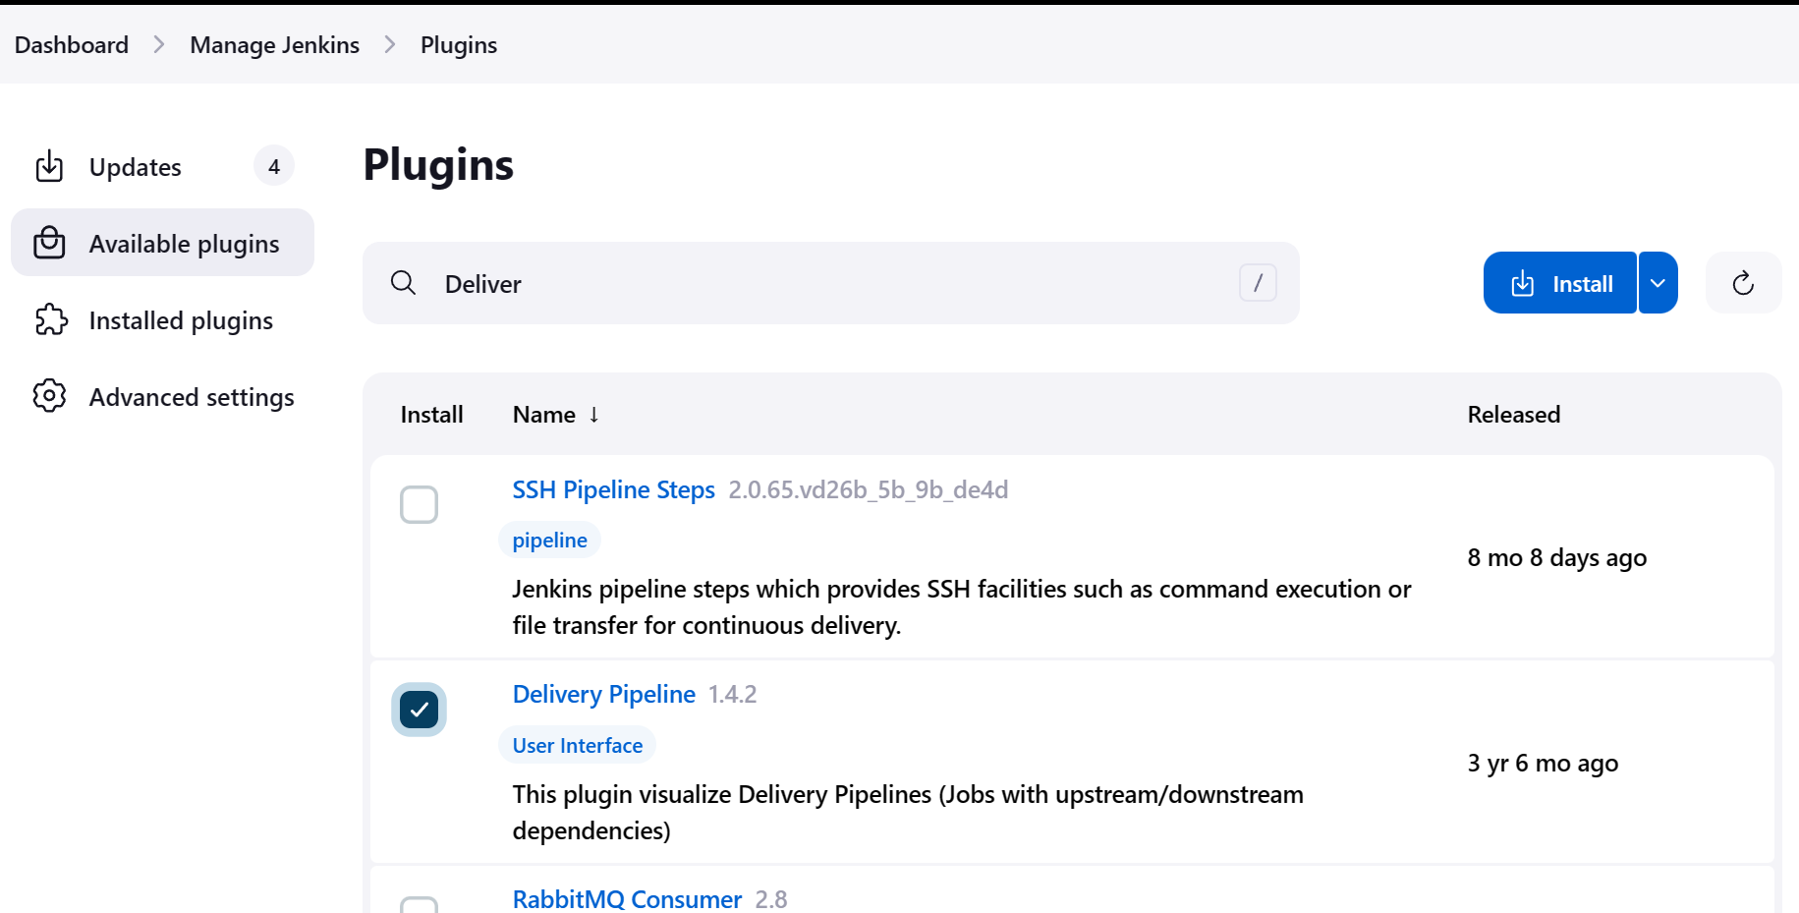

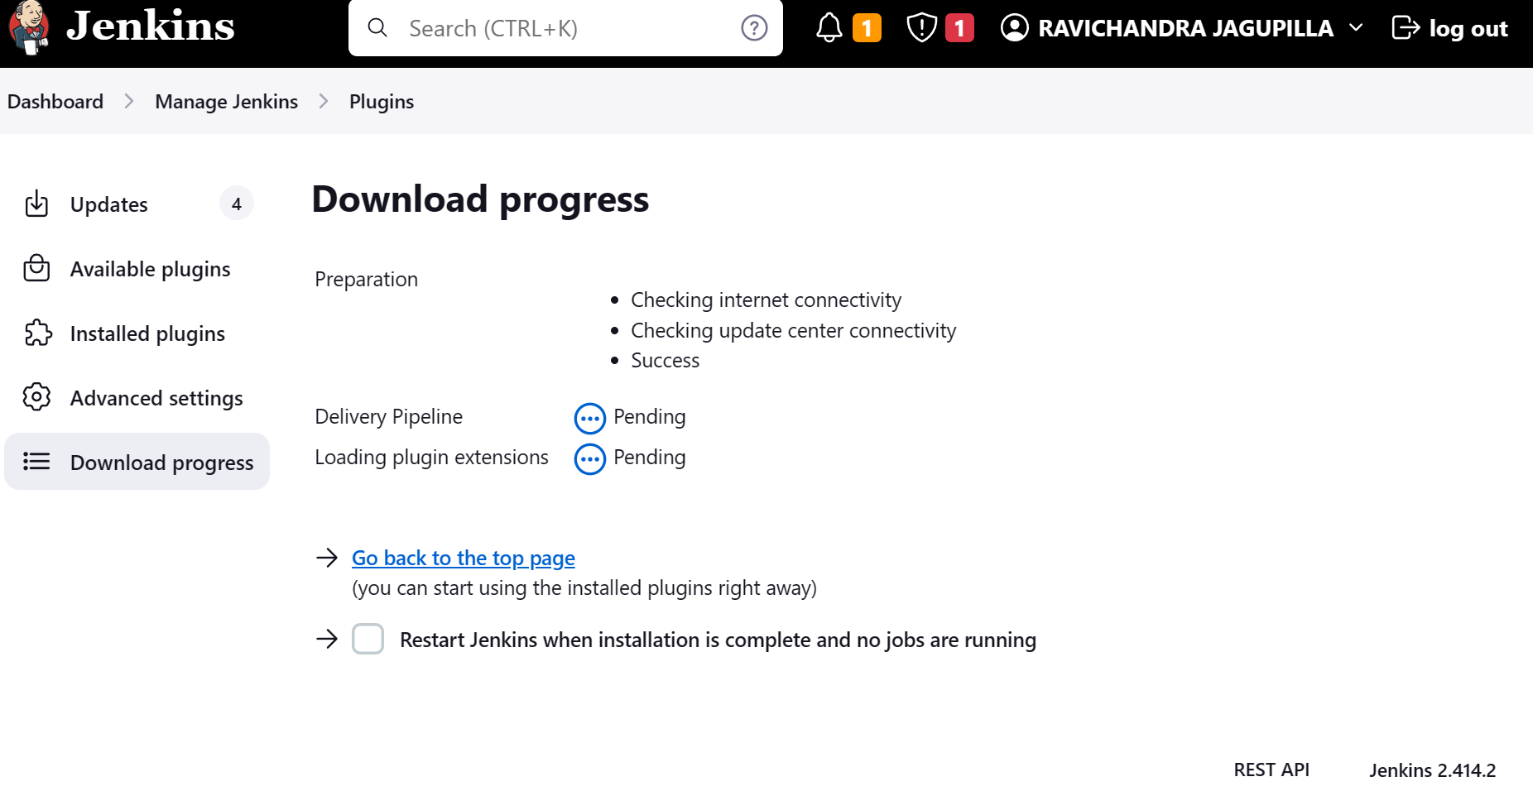

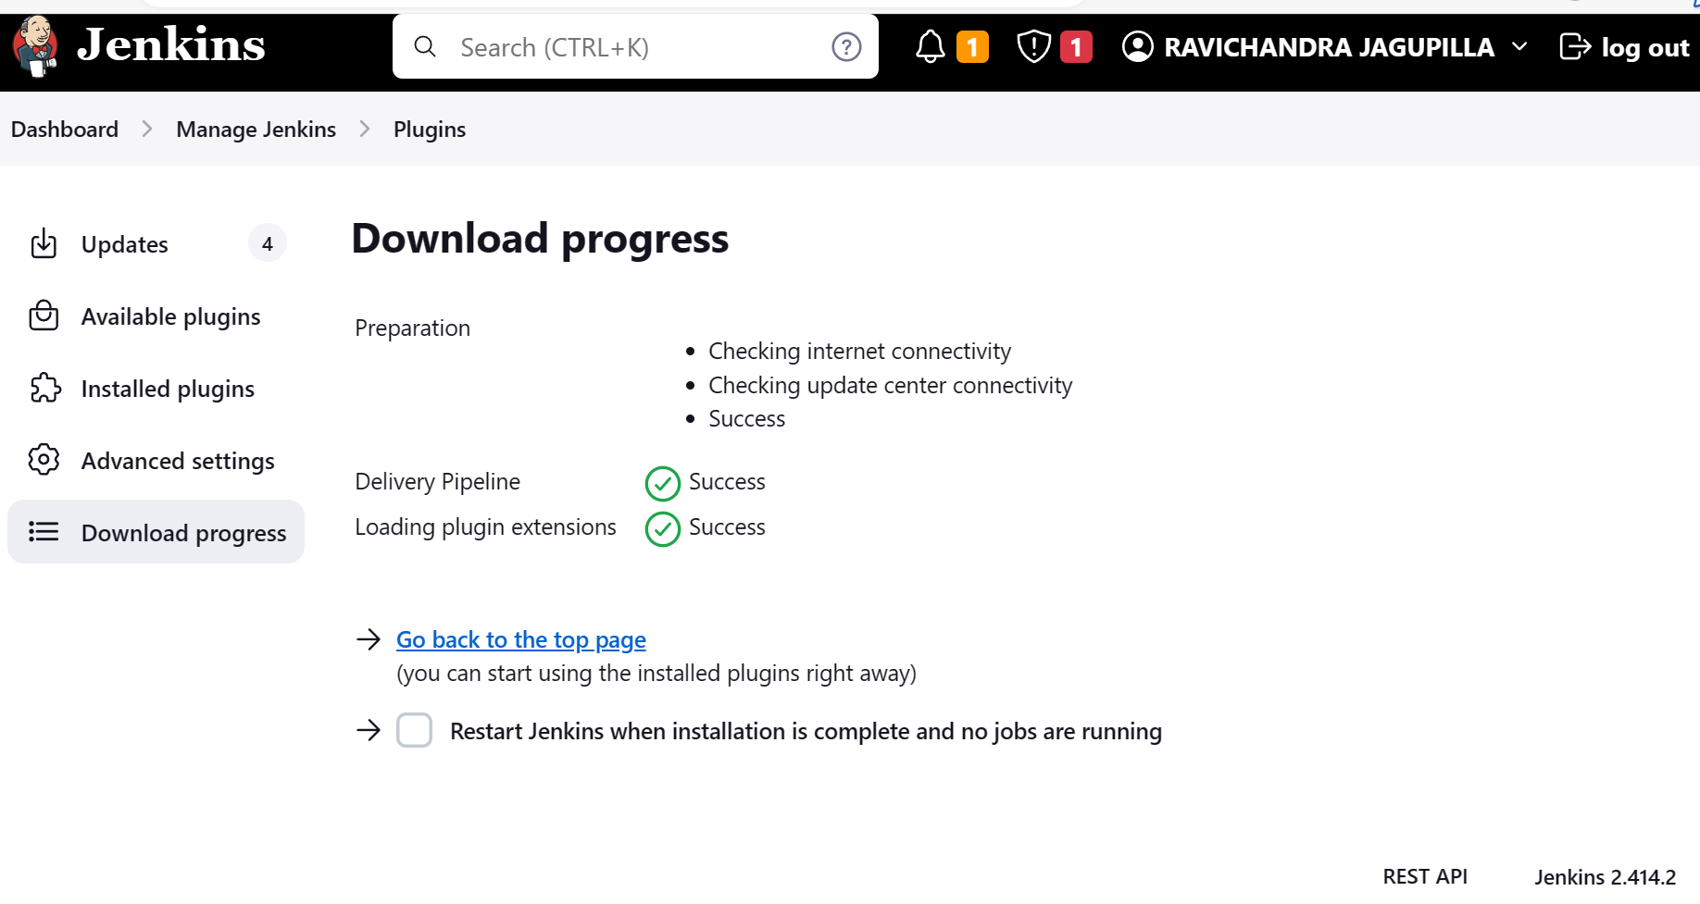

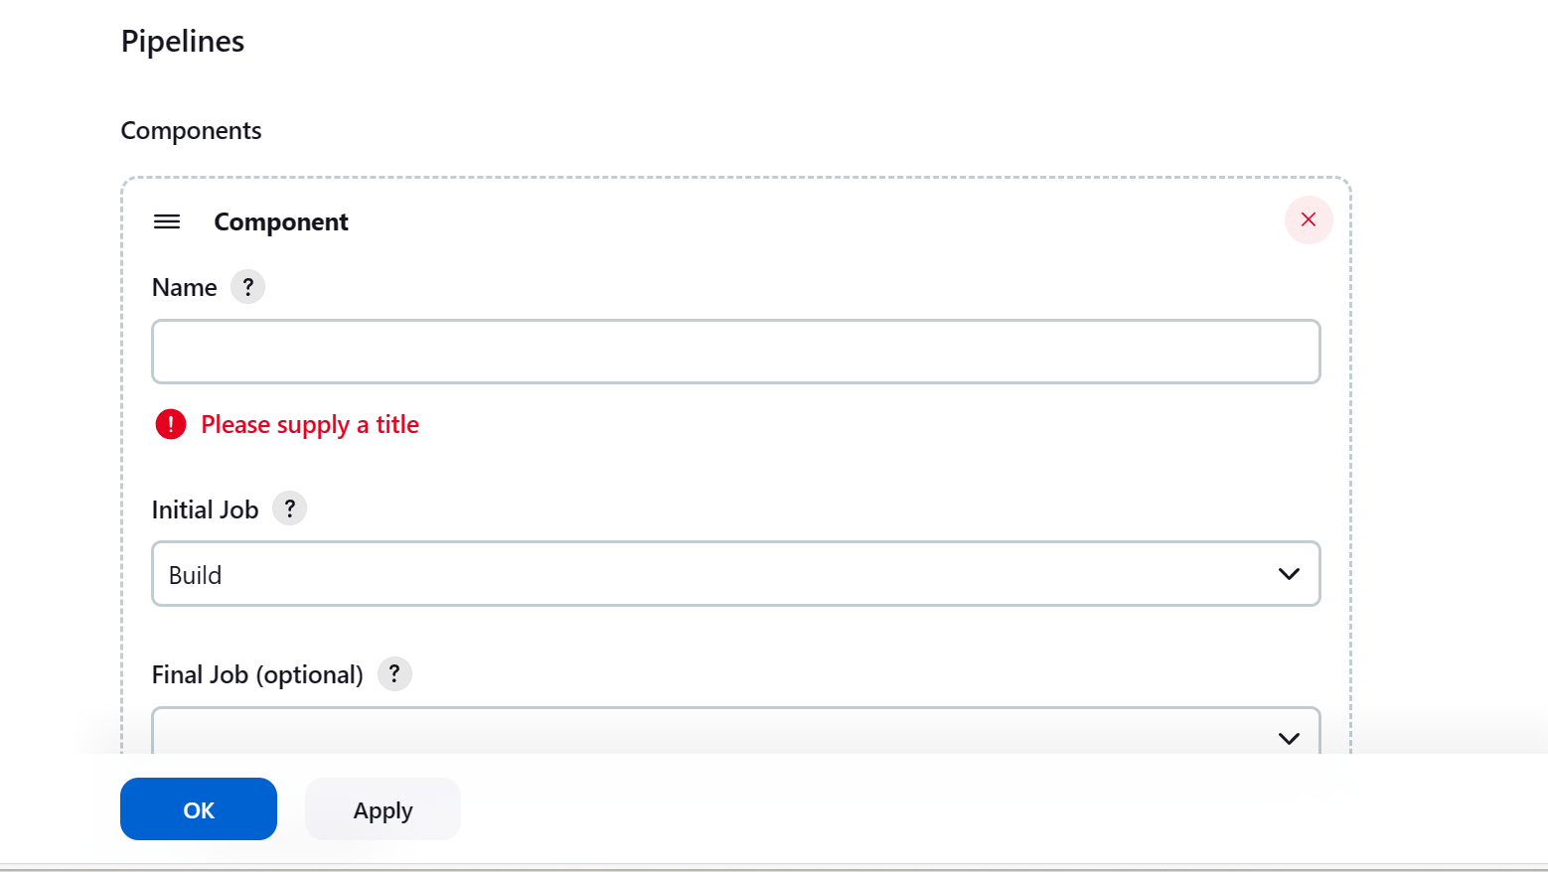

Click on pipeline

Componenet and give intial job name.

